Identify the personal protective equipment indicated in the picture, and why it is used.
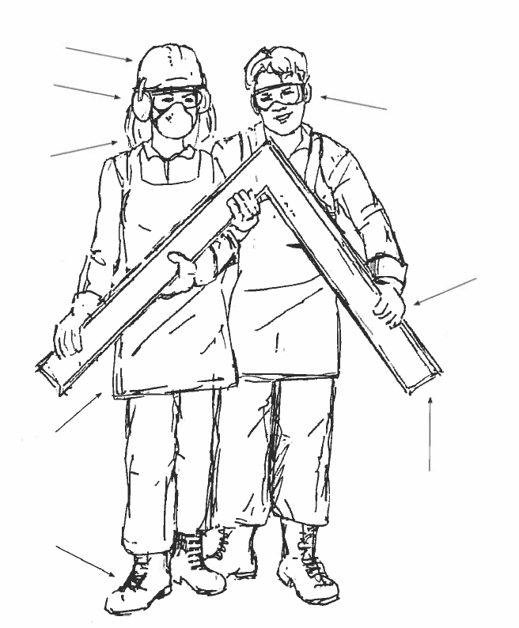
1.
2.
3.
4.
5.
6.
7.
8.

